**RAJALAKSHMI ENGINEERING COLLEGE**

**RAJALAKSHMI NAGAR, THANDALAM – 602 105**



|  |
| --- |
| **CS23A34**  **USER INTERFACE AND DESIGN LAB** |
| **Laboratory Observation NoteBook** |

**Name :** SANJAY KUMAR.K

# Year/Branch/Section : II/CSE/C

# Register No. : 230701289 Semester : IV Academic Year: 2024-25

**Ex. No. : 7b Date : 07.04.2025**

**Register No. : 230701289 Name : Sanjay kumar.k**

**Develop low-fidelity paper prototypes for a banking app and convert them into digital wireframes using Inkscape**

**AIM:**

The aim is to construct low-fidelity paper prototypes for a banking app and digitize them into wireframes using Inkscape.

Tool Link: https://inkscape.org/

**PROCEDURE:**

Step 1: Create Low-Fidelity Paper Prototypes

1. Identify Core Features:
   1. Determine the essential features of the banking app (e.g., login, dashboard, account management, transfers).

1. Sketch Basic Layouts: ○ Use plain paper and pencils to sketch the main screens. ○ Focus on the primary elements like buttons, navigation menus, and input fields.

1. Iterate and Refine: ○ Get feedback from users or stakeholders.
   1. Make necessary adjustments to improve clarity and functionality.

Step 2: Convert Paper Prototypes to Digital Wireframes Using

Inkscape

1. Install Inkscape:
   1. Download and install Inkscape from the official website.
2. Create a New Document: ○ Open Inkscape and create a new document by clicking on File > New.
3. Set Up the Document:
   1. Set the dimensions and grid for your design. Go to File > Document Properties to adjust the size.

○ Enable the grid by going to View > Page Grid.

1. Draw Basic Shapes: ○ Use the rectangle and ellipse tools to draw the basic shapes for your UI elements (e.g., buttons, input fields, icons).
2. Add Text:
   1. Use the text tool to add labels and placeholder text to your elements. 6. Organize and Align: ○ Arrange and align the elements to match your paper prototype.

○ Use the alignment and distribution tools to keep everything organized.

1. Group Elements:
   1. Select related elements and group them together using Object > Group.

○ This helps keep your design organized and easy to edit.

1. Create Multiple Screens: ○ Duplicate your base layout to create different screens (e.g., login,dashboard, transfer).
   1. Use Edit > Duplicate to create copies of your elements and arrange them for each screen.
2. Link Screens (Optional): ○ If you want to show navigation flows, you can add arrows or other indicators to demonstrate how users will move between screens.
3. Export Your Wireframes:

○ Once you're satisfied with your digital wireframes, export them by going to File > Export PNG Image.

○ Choose the appropriate settings and export each screen as needed.

**OUTPUT:**

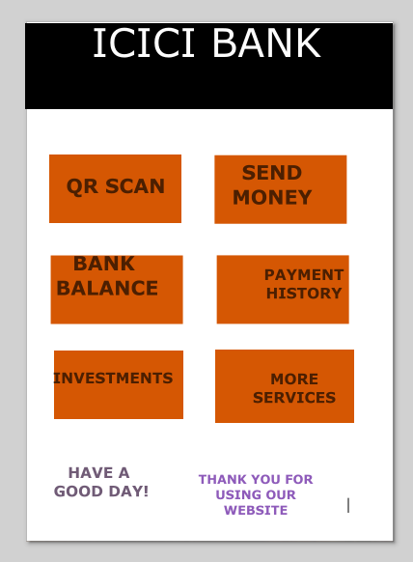

**RESULT:**

Hence, low-fidelity paper prototypes for a banking app and digitize them into wireframes using Inkscape have been executed successfully.